**Add User by Programmatic Access (Access Key and Secret key)**

* Login to your IAM console
* In the left navigation panel choose **Users** in **Access Management** section.
* Click on **Add Users**

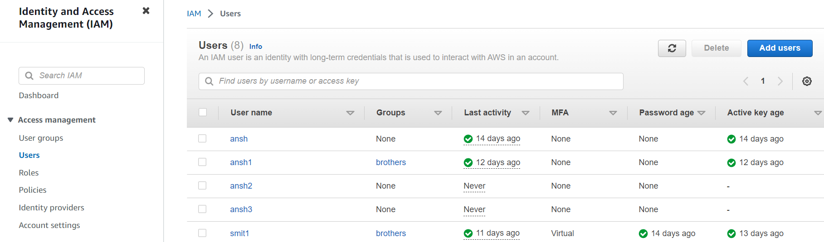

**Step 1 :- Specify user details**

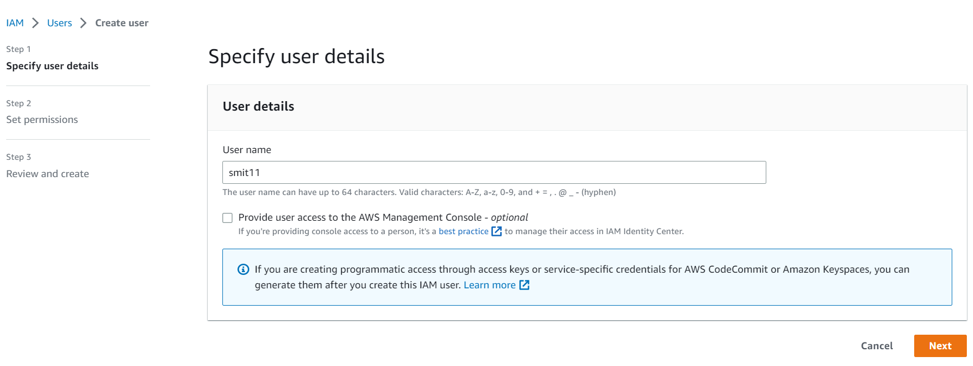

* Enter **User name**
* Do not enable **Provide user access to the AWS Management Console**
* Click on **Next**

**Step 2 :- Set Permissions**

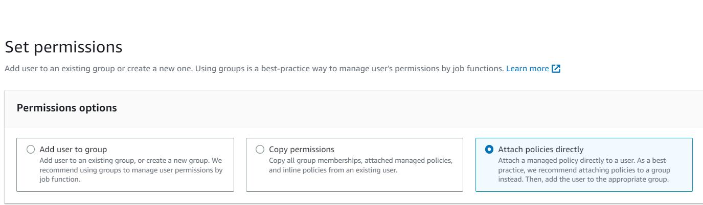

* In Permission Options select **Attach policies directly**

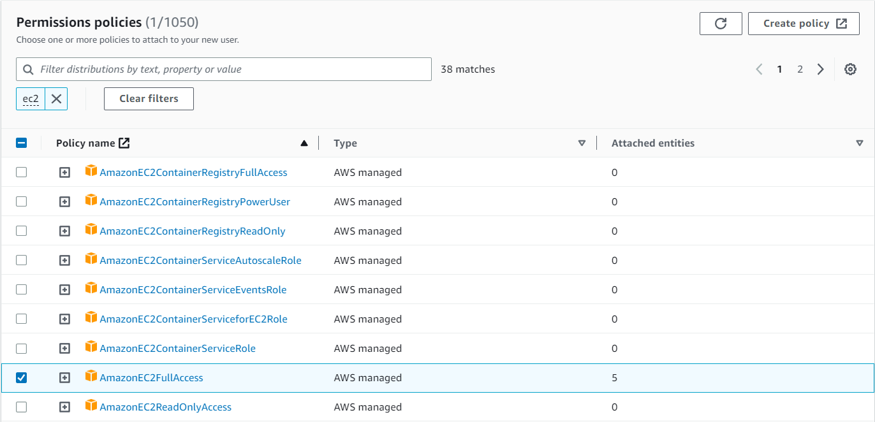

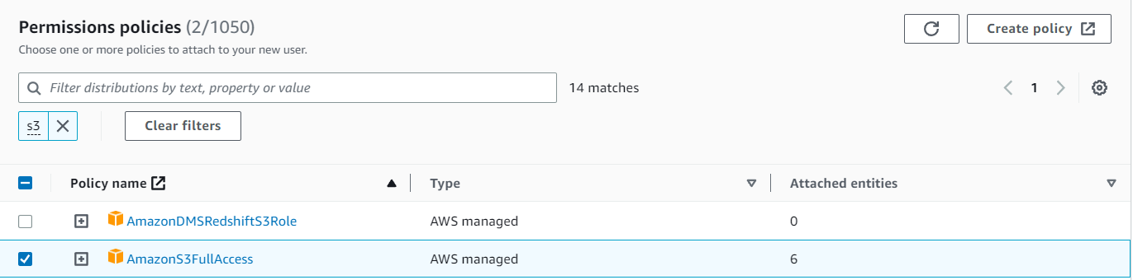



* In Permissions policies select **AmazonEC2FullAccess**, **Amazon S3FullAccess** and **IAMFullAccess**

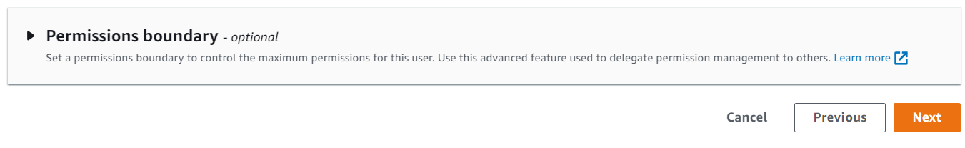

* We can set **Permissions boundary** to control the maximum permissions for this user. Use this advanced feature used to delegate permission management to others.
* Click on **Next**

**Step 3 :- Review and create**

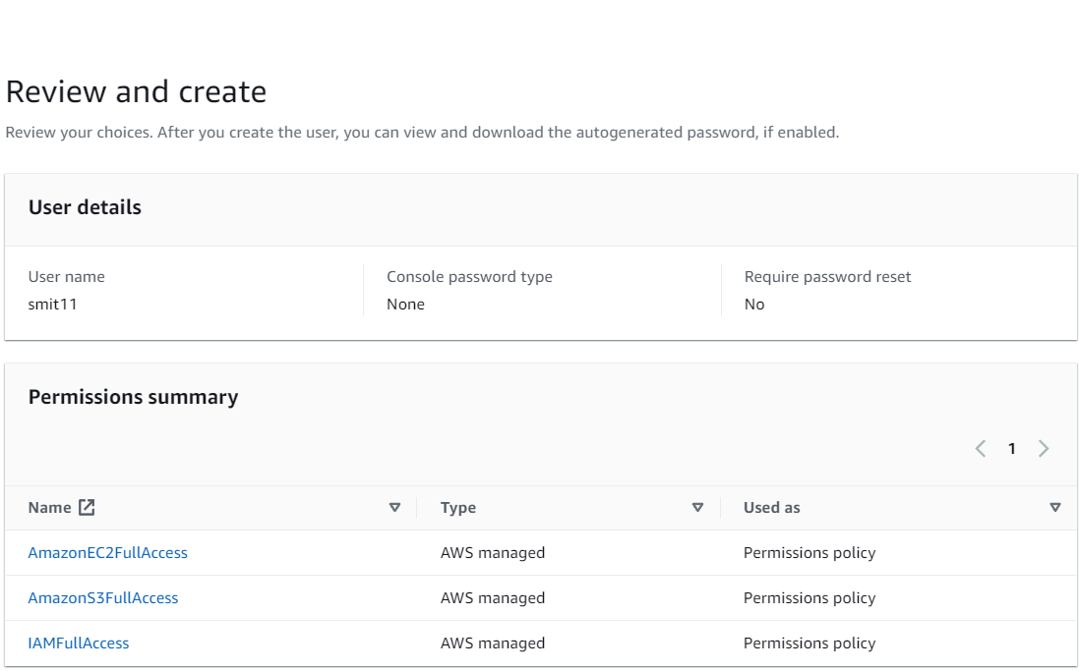

* We can add **Tags** to AWS resources to help identify, organize, or search for resources.

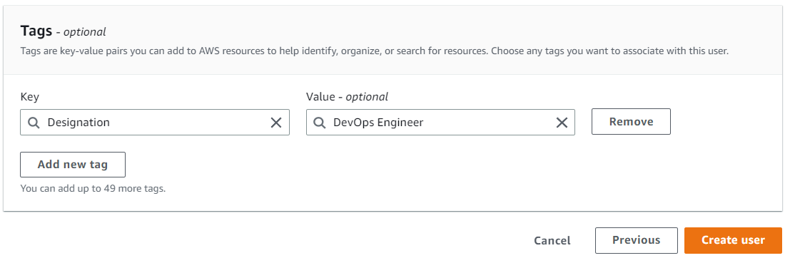

* Click on **Create user**
* So now user **“smit11”** has been created in users list by using Programmatic Access.
* **To Create Access Keys**
* Click on username **“smit11”** from **users list.**

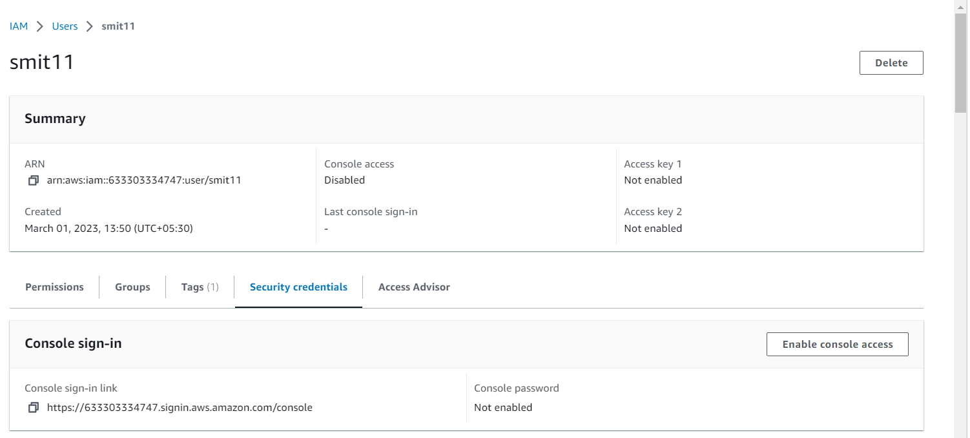

* Go to option **Security credentials** and scroll down to **Access keys** option.

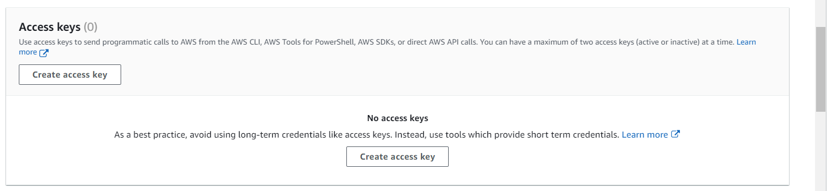

* Click on **Create access key**

**Step 1 :-** **Access key best practices & alternatives**

* 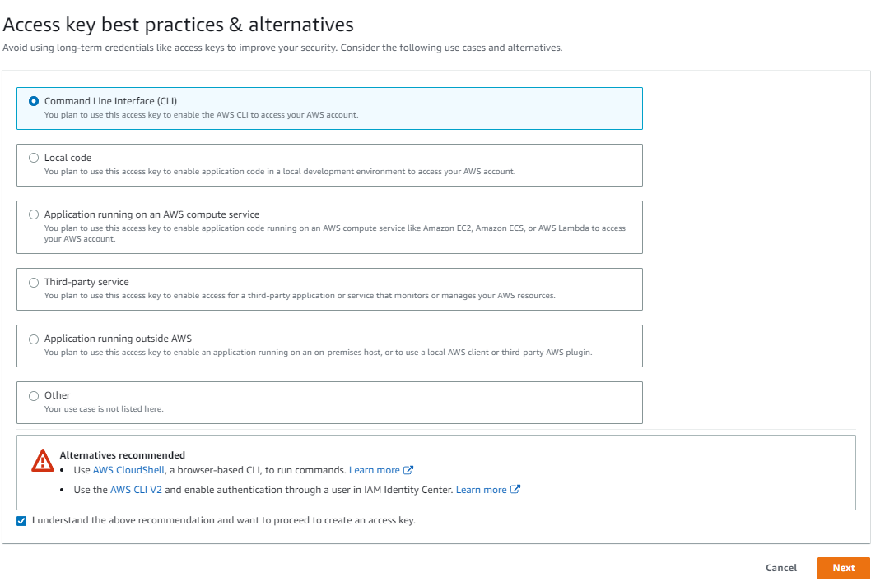Select Command Line Interface (CLI)
* Select box [ ] **I understand the above recommendation and want to proceed to create an access key.**
* Click on **Next**

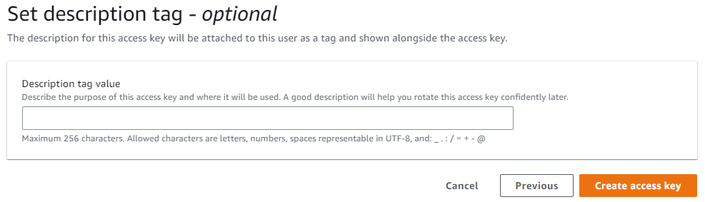**Step 2 :-** **Set description tag**

* Click on **Create access key**

**Step 3 :-** **Retrieve access keys**

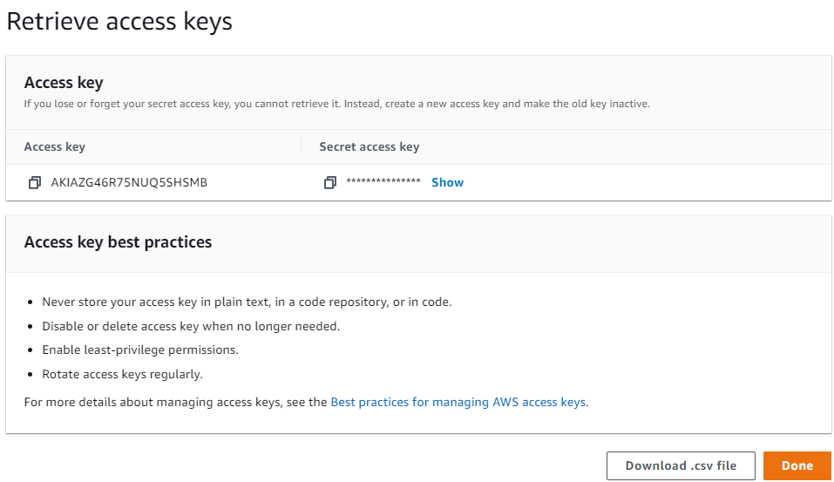

* So now we can copy **Access key** and **Secret Access** key in notepad or **Download .csv file**.
* **Now take access of user machine in instance by using Programmatic Access (Access and Secret Access Keys)**
* Login to your EC2 console
* Launch **EC2 instance** and **Connect**

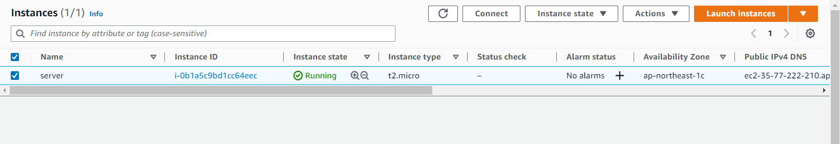

* Use command “**aws configure”** to take access in user machine and enter
  + AWS Access Key ID
  + AWS Secrets Access Key
  + Default region name
  + Default output format

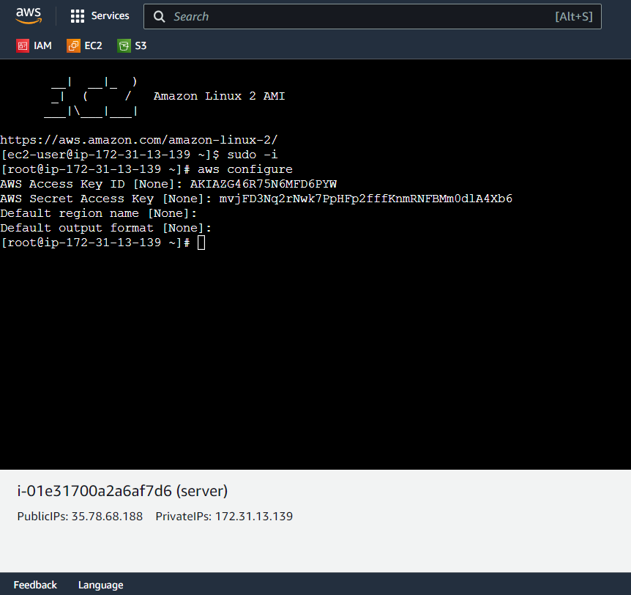

* Now you have been accessed in user’s machine by using Programmatic Access.
* And we can see the buckets and its contents because we have set permission (**attached policies of EC2, S3 and IAM services**).
  + By using **“aws s3 ls”** command , list buckets
  + By using **“aws s3 ls smitbucket11”** command, can see contents in bucket **‘smitbucket11’**
* To add User by using terminal
  + **aws iam create-user –user-name username**

